
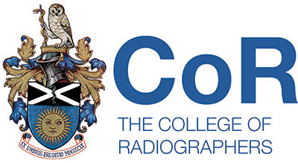
Scottish Council of the
Society of Radiographers
20/08/19, 11.00am
STUC Building
333 Woodlands Rd
Glasgow G3 6NG
Agenda
- Welcome to the committee

- Apologies

- Minutes of previous meeting

- Matters arising from the minutes

- Items for AOB:
  - UK Council Vacancy update
  - Cabinet Minister meeting
  - SRTP / SCIN update
  - AGM 19
  - Advance Practitioner litigation case update
  - Managing GDPR in SC business (discuss at next meeting)
  - Treasurer role & membership

- Correspondence

- Scottish Council Work plan

- UK Council Report

- Professional Officer Report

- National Officer Report

- Executive Reports

- AOCB

Date of next meeting: 14th November 2019

