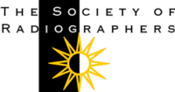

SATURDAY 28th OCTOBER 2017
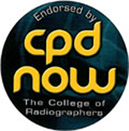

SCOTTISH COUNCIL STUDY DAY & AGM

MERCURE HOTEL, GLASGOW

PROGRAMME

9.30 – 10.00 Registration, Tea/Coffee & Danish Pastries

10.00 – 10.05 Welcome
Victoria Russell, Chair of Scottish Council

10.05 – 10.40 Emergency Medical Retrieval Service
Alistair Maddock , Consultant Anaesthetist

10.40 – 11.10 HCPC Audit – What if you are selected??
Rae Dickson, HCPC Audit Assessor & Retired Superintendent Radiographer

11.10 – 11.40 Tea/Coffee & Scones

11.40 – 12.20 Case Studies

Kelsey Normand – Specialist Therapy Radiographer
The Radiotherapy needs of GP’s
Dr Jonathon McConnell – Consultant Reporting Radiographer
Kirsty Mullan – Specialist Diagnostic Radiographer –
Spontaneous Coronary Artery Dissection

12.20 – 1.00 Beautiful Inside & Out (SCIO)
Pauline Moriarty founder of charity, borne out of the tragic suicide of
Jenna Moriarty aged 13

1.00 – 2.00 Lunch
2.00 - 2.20 President’s Address – Gareth Thomas
2.20 – 2.35 ADC 2017 –Caroline Handley & Kelsey Normand
2.35 – 3.30 Scottish Council AGM &Extraordinary UK Council meeting - Political Fund Update – Richard Evans OBE
Nominations for Scottish Council vacancies
Elections and Raffle

