 | 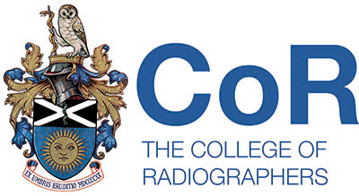  Scottish Council of the  Society of Radiographers  06/03/19 11.00am  STUC  333 Woodlands Rd  Glasgow G3 6NG
Agenda
- Welcome to the committee

- Lifecurve app presentation – Susan Kelso

- Minutes of previous meeting

- Matters arising from the minutes

- Correspondence

- UK Council Report

- Professional Officers Report

- Executive Reports

- Any item for AOCB

– Scottish Council Work plan
- UK Council Vacancy

- AOCB

Date of next meeting: 20th June 2019

