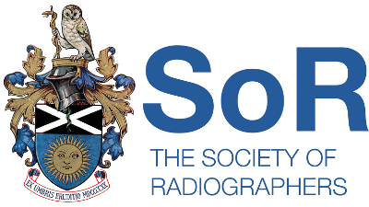 | 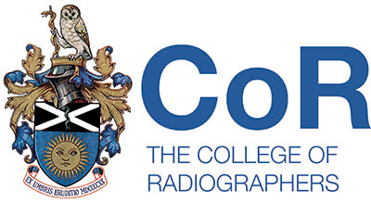  Scottish Council of the  Society of Radiographers  08/01/19 11.00am  STUC  333 Woodlands Rd  Glasgow G3 6NG
Agenda
- Welcome to the committee

- Any item for AOCB

- Minutes of previous meeting

- Matters arising from the minutes

- Correspondence

- UK Council Report

- Professional Officers Report

- Executive Reports

- AOCB

Date of next meeting: 6th March 2019

